Use Case Realisation Report - Manage ProjectPost Feedback
FOR
Volunteer Management System
(VMS)

CLIENT
PROJECT | Volunteer Management System (VMS)
TITLE | Use Case Realisation Report - Manage ProjectFeedback
VERSION | 0.1a
DATE | 13-Aug-2011
 | ORIGINATOR
 | Name / Signature | Team 8S
 | APPROVAL
 | Name / Signature | Phung Kim Cuong, Dio
Institute of Systems Science |  | Document Reference
25 Heng Mui Keng Terrence  Singapore 119615 |  | VMS/PM-1.3.1/1

 | Acceptance
 | Customer Signature |  | Customer Signature
 | Name & Designation |  | Name & Designation
 | Date & Company Stamp |  | Date & Company Stamp

Revision History

Date | Version | Description | Author
12-Jun-2011 | 0.1a | Creation | Team 8S
 |  | Refer to amendment history

Table of Contents

1. Brief Description 3
2. Flow of Events 3
2.1 Standard Flow 3
2.2 Exceptions 3
3. Interaction Diagrams 3
3.1 Domain Collaboration Diagram: Post Feedback 3
4. Participating Objects 4
5. Derived Requirements 4
6. Derived Requirements 4
ANNEX D Amendment History 4

Use-Case Realization Report
Post Feedback

Brief Description
The use case enables registered user to propose new project.

Flow of Events
The standard flow of events for this use case and any exceptions are described in the following subsections. See section 3.1 for an overview of the participating Actors and Domain Objects.

Standard Flow

Precondition: Volunteer has logged in the system and use case 4.6 has been executed

This use case provides the user interface related functionality that will be provided to the User, as follows:
- When the Volunteer clicks ‘Post Feedback’ button on the ProjectDeatilsScreen, the addUserStory() method of ProjectDeatilsScreen is triggered.
- ProjectDeatilsScreen uses the method redirectURL() of ProjectController to display the UserFeedbackScreen to Volunter
- After the show() method of UserFeedbackScreen is triggered, an new form will be displayed enabling volunteer to enter text.
- Volunteer can also upload supporting document or attach images
- After user click ‘submit’ button, UserFeedbackScreen will use the saveFeedback() method to save the user input information to data persistence
- ProjectController will create a new UserFeedback object with user input info and save to data persistence layer
- ProjectController will create one or more Document objects to save user uploaded docs or images
- ProjectController will use the displayMsg() of UserFeedbackScreen to display a confirmation msg to the volunteer.
- The volunteer can continue add feedback.
.

Exceptions
The following exceptions have been identified:
- Invalid Information Format. If any of input info is incompatible, system will give a validation summary for user to make corrections

Interaction Diagrams

Domain Collaboration Diagram: Post Feedback
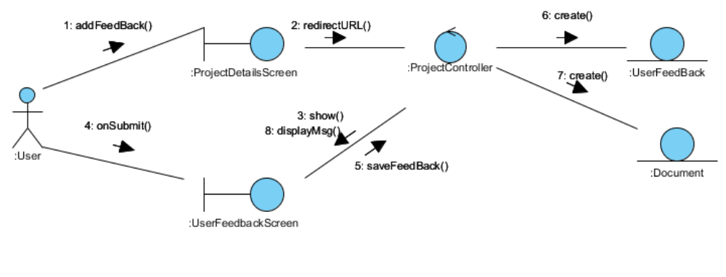

Participating Objects
:
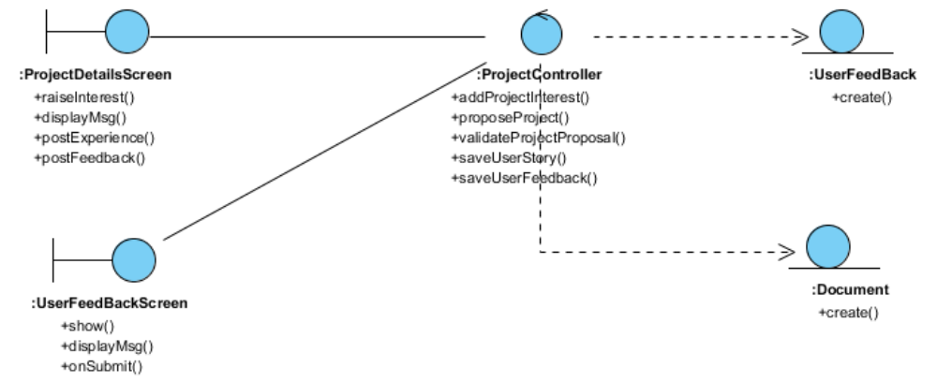

Derived Requirements

:

Derived Requirements

ANNEX D Amendment History

This is a record of all amendments made to the Document.
Version | Chapter / Section | Page No | Notes of Amendments or Changes

